**APARTMENT MANAGEMENT SYSTEM (AMS)**

* **CONTRIBUTORS**

1. Khawaja Abdul Moiz
2. Muhammad Harim
3. Areeb Alvi

* **Purpose:**

The purpose of an "Apartment Management System" is to facilitate efficient and organized management of various tasks and processes related to the administration and maintenance of apartment complexes or residential buildings. The system is designed to streamline operations for property managers, tenants, and other stakeholders. Here are some common purposes of an Apartment Management System:

**Tenant Management:**

* Keep track of tenant information, including contact details, lease agreements, and payment history.
* Automate the process of tenant onboarding and off boarding.

**Rent and Billing:**

* Manage rent collection, generate invoices, and keep a record of payment transactions.
* Provide automated reminders for upcoming rent payments.

**Maintenance Requests:**

* Allow tenants to submit maintenance requests through the system.
* Streamline the process of assigning and tracking maintenance tasks.
* Amenities and Facilities Management:
* Keep a record of available amenities and facilities in the apartment complex.
* Schedule maintenance and cleaning for shared spaces such as gyms, pools, and common areas.

**Communication:**

* Facilitate communication between property managers and tenants.
* Provide a platform for announcements, notifications, and updates.

**Security and Access Control:**

* Implement features for managing access control, such as keyless entry systems or visitor management.
* Keep track of security-related incidents and measures.

**Document Management:**

* Store and manage important documents related to property ownership, contracts, and legal agreements.

**Financial Reporting:**

* Generate financial reports for property owners and managers.
* Keep track of expenses, revenue, and overall financial health of the property.

**Occupancy and Vacancy Tracking:**

* Monitor and manage the occupancy status of individual units.
* Plan for upcoming vacancies and coordinate leasing efforts.

**Compliance and Regulations:**

* Ensure compliance with local regulations and housing laws.
* Store relevant compliance documentation.

By addressing these aspects, an Apartment Management System aims to enhance the overall efficiency of property management, improve communication between stakeholders, and create a more convenient and enjoyable living experience for tenants.

* **Functionality:**

The functionality of an Apartment Management System encompasses a wide range of features to address the needs of property managers, tenants, and other stakeholders involved in the management of residential complexes. Here are the key functionalities typically found in such a system:

1. User Authentication and Authorization
2. Tenant Information Management
3. Rent and Billing Management
4. Maintenance Request System
5. Amenities and Facilities Management
6. Communication Platform
7. Security and Access Control
8. Document Storage and Management
9. Financial Reporting
10. Occupancy and Vacancy Tracking
11. Compliance Monitoring
12. Analytics and Reporting
13. Data Security and Privacy

By incorporating these functionalities, an Apartment Management System aims to automate and streamline various aspects of property management, enhancing the overall efficiency and experience for both property managers and tenants.

* **Usage Instructions for AMS:**

Usage instructions for an Apartment Management System. Note that these are general guidelines, and the specifics may vary based on the actual implementation and technology stack used in the project.

1. **User Registration and Login:**

* **For Property Managers:**
* Register with the system using a valid email address.
* Log in using the registered credentials.
* **For Tenants:**
* Receive login credentials from the property manager or use a self-registration feature.
* Log in to the system.
* 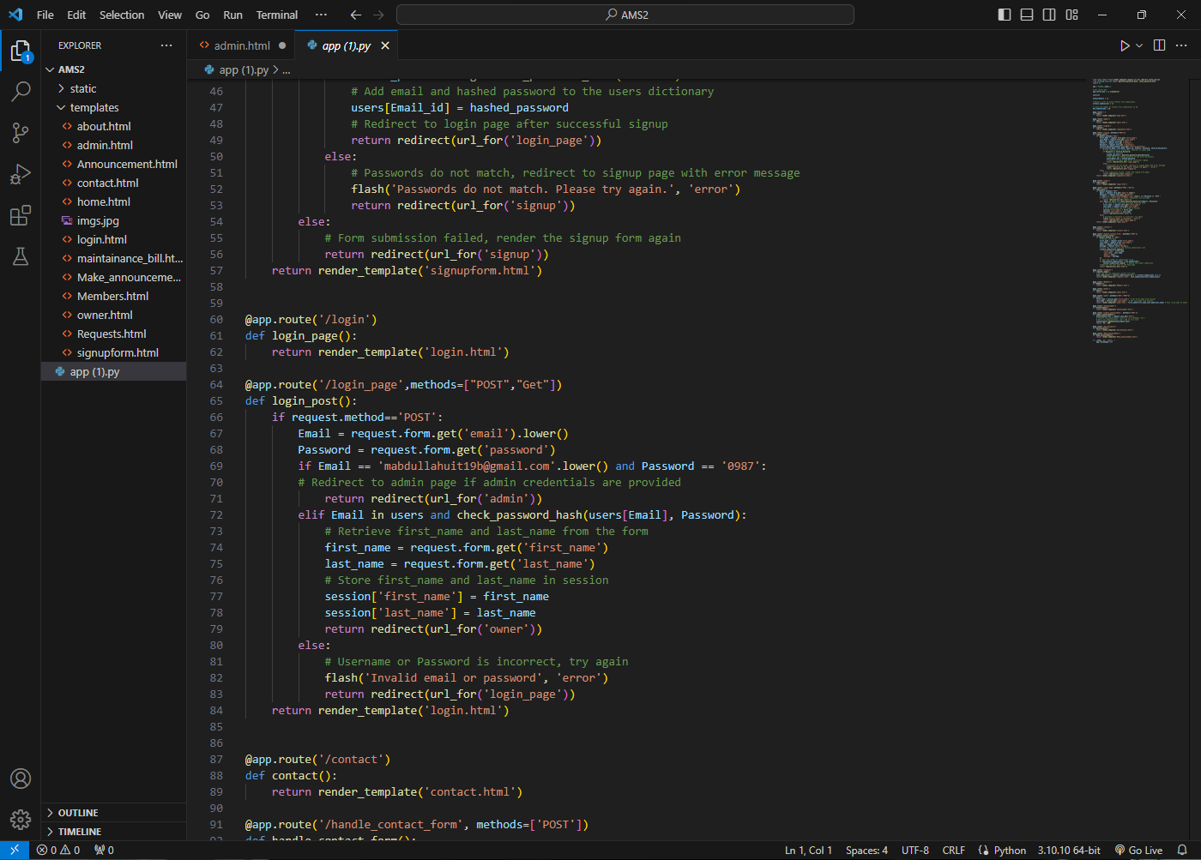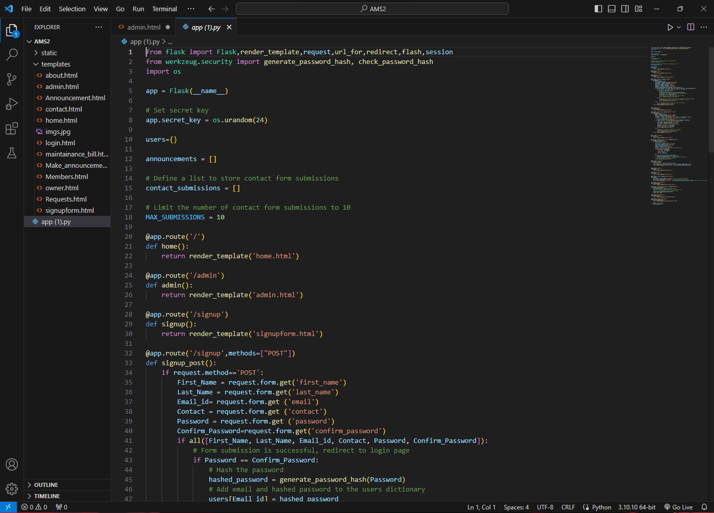**Screen Shots:**

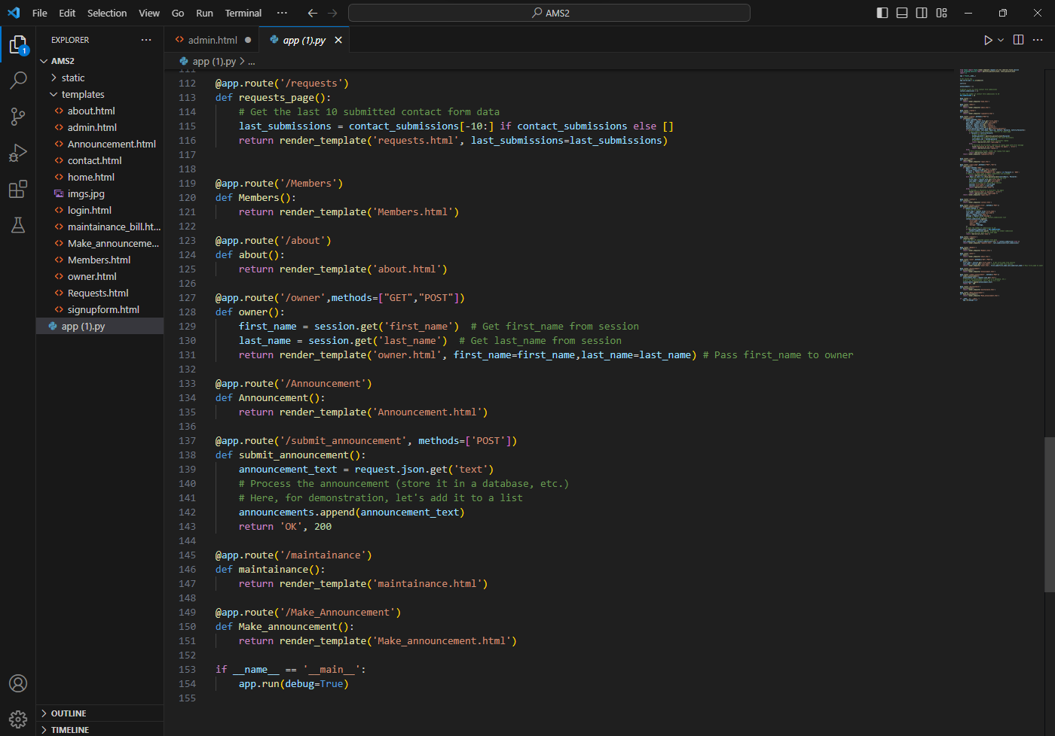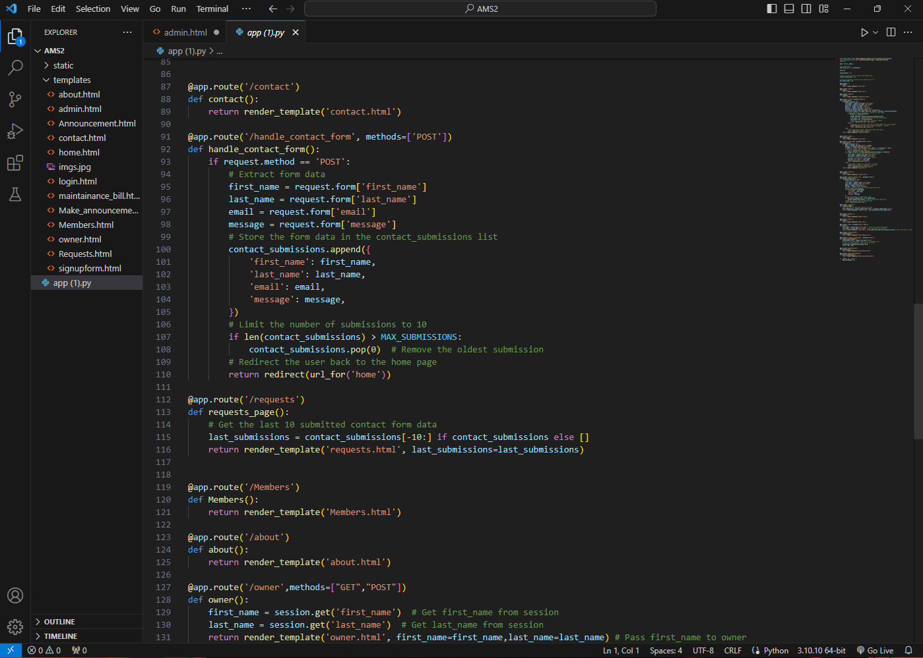

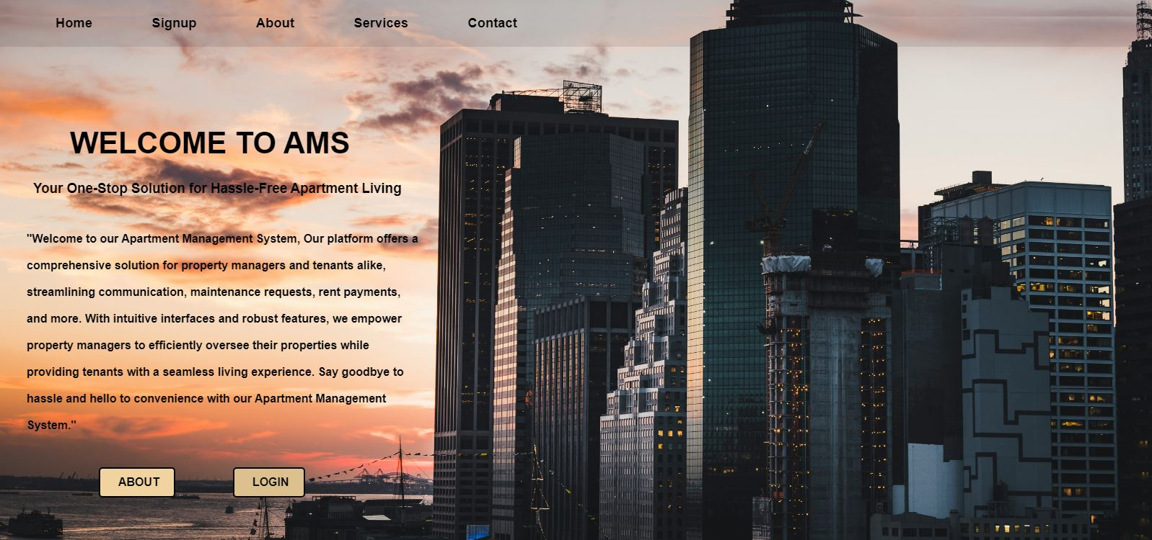

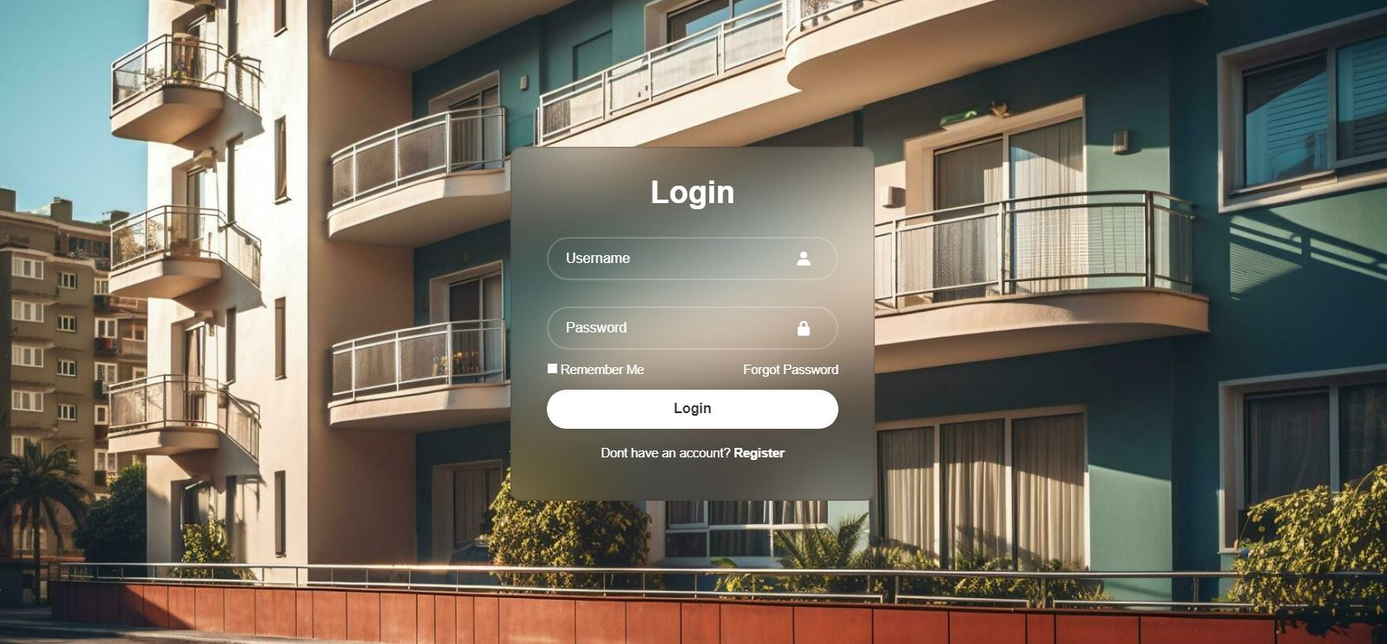

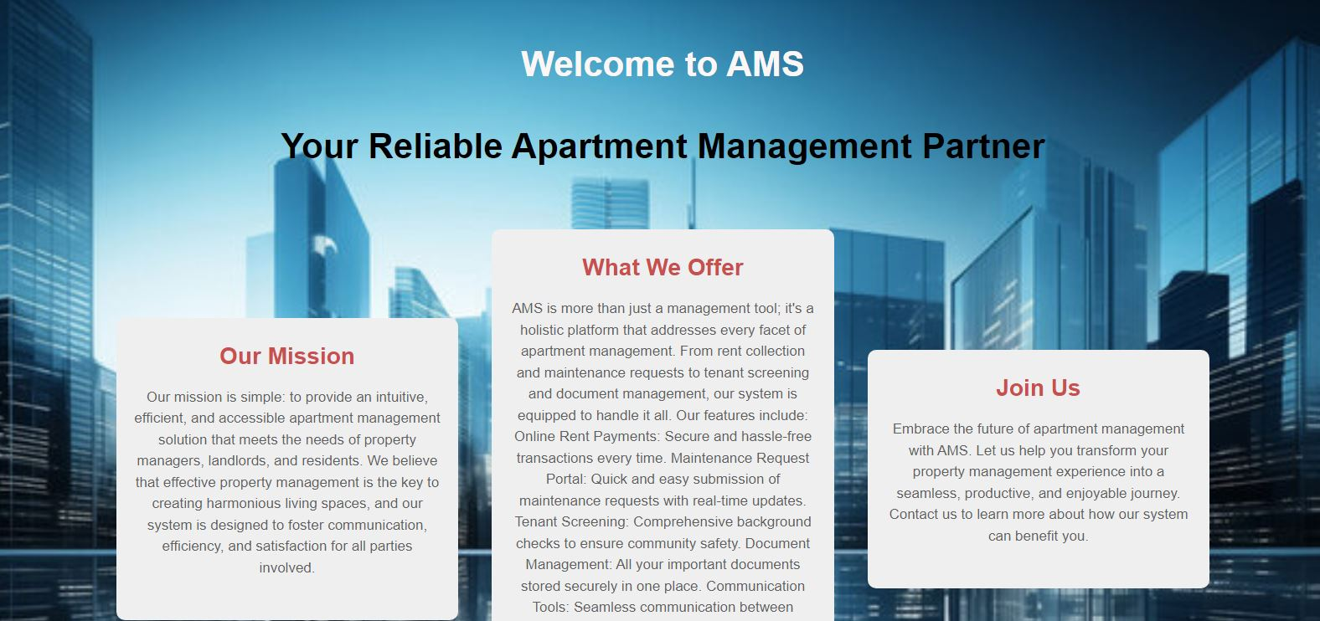

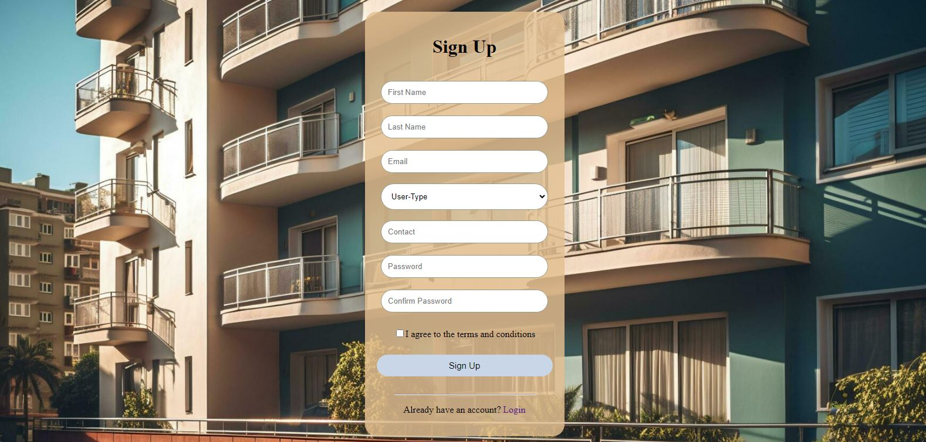

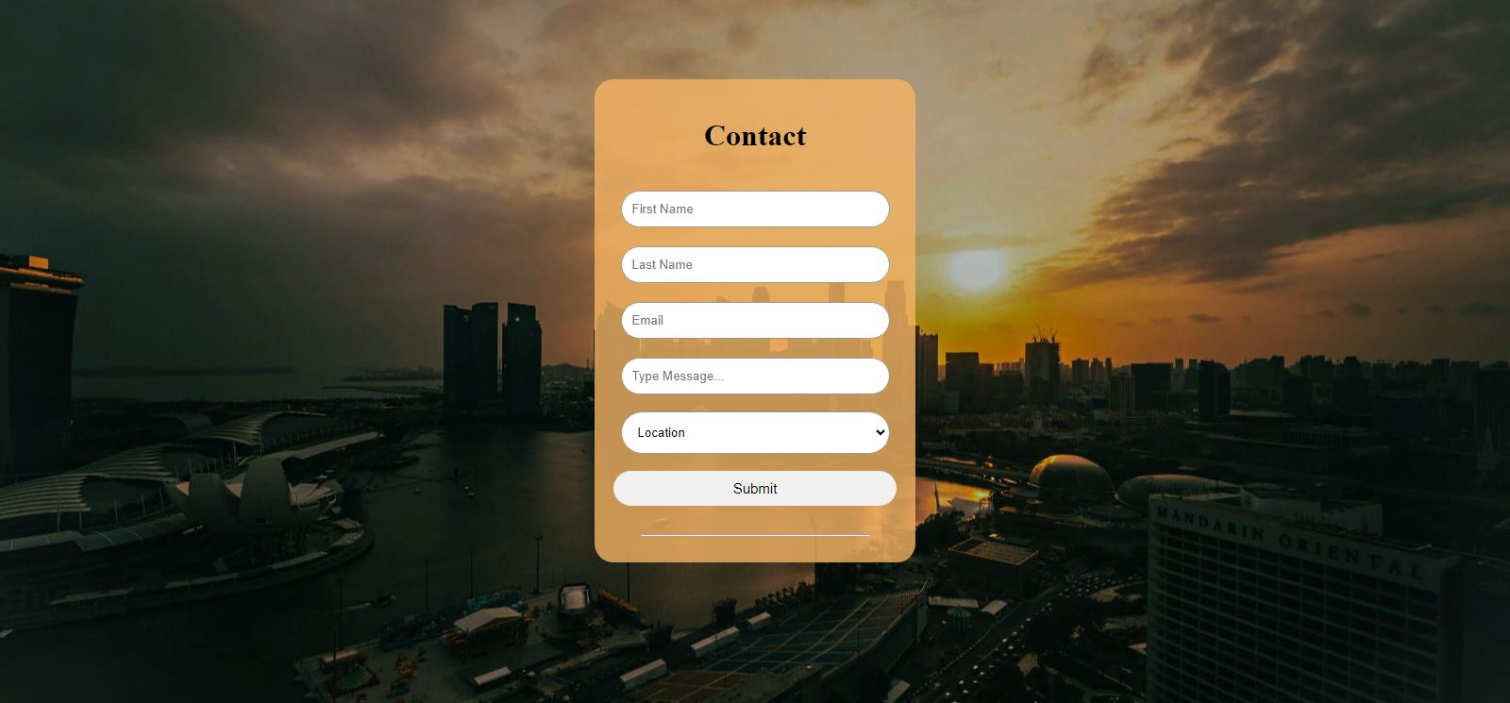

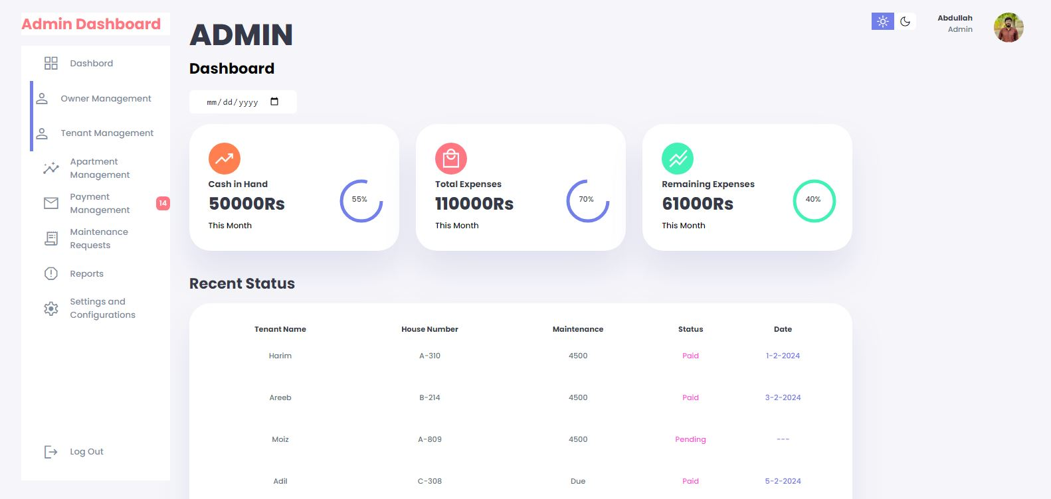

* **Links:**

**1.Github:**

<https://github.com/KhawajaAbdulMoiz/.AMS>

**2.Video:**

<https://www.facebook.com/share/v/koLkwi4Vv4XqMPot/?mibextid=w8EBqM>